Insights into Spectra-Physics’ InSight DeepSee
William Giang
2022-09-25
Table of contents

Overview
We thought the Nikon A1R MP’s laser system, the Spectra-Physics InSight DeepSee, was in need of repair. After contacting the service engineer for Spectra-Physics, we learned two laser diodes were already replaced with a bill of $30k. We were also warned that the laser power had been reduced, but otherwise the DeepSee should be functional.
- The liquid in the chiller unit has been flushed and replaced with coolant.
- After turning on the microscope and laser systems, it took several days for the laser’s humidity to reach acceptable levels
- The power output has been reduced
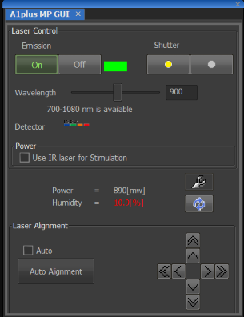
Image of A1plus MP GUI
import pandas as pd
import seaborn as sns
import matplotlib.pyplot as plt

How long does the InSight DeepSee need to effectively warm up?
Sept 20: Turned on all scope components and noticed humidity was too high, so I started logging it
humidity_csv = "Time_since_DeepSee_turn_on.csv"
humidity_df = pd.read_csv(humidity_csv)
humidity_plot = sns.scatterplot(data = humidity_df,
x = "Time [Minutes]",
y = "Relative Humidity [%]",
)
humidity_plot.set_title("Four days for humidity to stabilize from start-up")
humidity_plot.set_xlim(0, 4500)
(0.0, 4500.0)
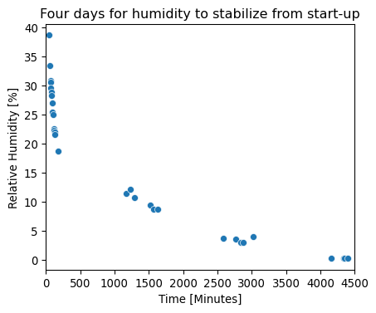

How much power did we lose as a function of wavelength?
- Digitized the theoretical tuning power from the manual
- There also appears to be a warmup time after turning emission ON
- Severe drop in power when laser is tuned above 1000nm
data_csv = "2022-09-23_laser-power-vs-wavelength_with-theoretical.csv"
df = pd.read_csv(data_csv)
palette = sns.color_palette("mako_r", 5)
sns.set_theme(style="whitegrid")
g = sns.scatterplot(data = df,
x = "Wavelength [nm]",
y = "Power [mW]",
hue = "Replicate",
style = "Replicate",
palette = palette,
)
g.set_title("InSight DeepSee far from spec \nat $\lambda$ > 1000nm")
g.set_xlim(700, 1100)
g.set_ylim(-20, 1400)
(-20.0, 1400.0)
