Spinning Disk Confocal PSFs with PSFmodels
William Giang
2023-06-04
Table of contents

Motivation
Obtaining an accurate point spread function (PSF) is vital for good deconvolution.
Here’s how to obtain the pinhole_au parameter for generating a confocal PSF in Talley Lambert’s PSFmodels.

Theory
A measure of confocality (in Airy units) is the ratio between the back projected pinhole radius and the radius of the Airy disk.
Since the back projected pinhole radius ($R_{BP}$) is the size of the pinhole radius projected on the sample plane, it can be calculated with the pinhole radius ($R_{PR}$) divided by the total magnification between the pinhole(s) and the sample, which includes the objective’s magnification ($M_{O}$) and other potential sources of intermediate magnification ($M_{I}$)
$$ R_{BP} = {R_{PR} \over M_{O} * M_{I}} $$
The radius of an Airy disk ($R_{A}$) is equivalent to Rayleigh’s lateral resolution criterion which is the product of 0.61 and wavelength ($λ$) divided by the numerical aperture ($NA$)
$$ R_{A} = 0.61 {\lambda \over NA } $$

Confocality with Yokogawa CSU-X1
With a physical pinhole radius of 25 microns, the Yokogawa CSU-X1 spinning disk unit is optimized for high resolution live-cell imaging, so we should expect a smaller confocality value when imaging with a high resolution objective than with a lower resolution objective.
Let’s compare the confocality between two objectives (100x/1.49 and 20x/0.75) when imaging EGFP (emission peak wavelength at 509nm).
Objective Mag | Objective NA | $λ$ (um) | Back Projected Pinhole Radius (um) | Airy Disk Radius (um) | Confocality (Airy units)
20x | 0.75 | 0.509 | 1.25 | 0.414 | 3
100x | 1.49 | 0.509 | 0.166 | 0.208 | 1.2
import psfmodels as psfm
import numpy as np
import matplotlib.pyplot as plt
from matplotlib.colors import PowerNorm
def backProjectedPinholeRadius(PinholeRadius, MagObjective, MagIntermediate=1):
"""
Return the back projected pinhole radius for a spinning disk confocal unit.
Parameters
----------
PinholeRadius : float
Physical radius of the pinhole
MagObjective : int
Magnification of the objective
MagIntermediate : float
Other magnification between the spinning disk and sample
Returns
-------
float
The `pinholeRadius` divided by both `MagObjective` and `MagIntermediate`
Examples
--------
>>> backProjectedPinholeRadius(25, 100)
0.25
>>> backProjectedPinholeRadius(25, 100, 1.5)
0.16666666666666666
"""
return PinholeRadius / (MagObjective*MagIntermediate)
def airyDiskRadius(wavelength, NA):
"""
Return the radius of an Airy Disk given a wavelength and numerical aperture.
Parameters
----------
wavelength : float
Wavelength
NA : float
Numerical aperture of the objective
Returns
-------
float
0.61 multiplied by `wavelength` and divided by `NA`
Examples
--------
>>> airyDiskRadius(509, 1.49)
208.38
>>> airyDiskRadius(509, 0.75)
413.99
"""
return 0.61 * wavelength / NA
def confocality(BackProjectedPinholeRadius, AiryDiskRadius):
"""
Return the confocality (in Airy Units) for a spinning disk confocal
Parameters
----------
BackProjectedPinholeRadius : float
The pinhole radius projected on the sample plane
AiryDiskRadius : float
The radius of an Airy Disk (also equivalent to Rayleigh's lateral resolution)
Returns
-------
float
The `BackProjectedPinholeRadius` divided by the `AiryDiskRadius`
Examples
--------
>>> confocality(0.25, 0.208)
1.2
>>> confocality(1.25, 0.6)
2.1
"""
return BackProjectedPinholeRadius/AiryDiskRadius
def plotConfocalPSF(params):
"""
Returns the confocal PSF while plotting lateral and axial views.
"""
nz = params["nx"]
ConfocalPSF = psfm.confocal_psf(**params)
fig, (ax1, ax2) = plt.subplots(1, 2)
ax1.imshow(ConfocalPSF[nz//2], norm = PowerNorm(gamma=0.4))
ax2.imshow(ConfocalPSF[:,params["nx"]//2], norm = PowerNorm(gamma=0.4))
ax1.set_title("lateral")
ax2.set_title("axial")
figtitle1 = "NA:{} | pinhole_au:{} | em_wvl:{}\n".format(
params["NA"],
round(params["pinhole_au"], 2),
params["em_wvl"],
)
figtitle2 = "sample RI:{} | immersion medium RI:{}\n".format(
params["ns"],
params["ni"]
)
figtitle3 = "depth:{} | model:{}".format(
params["pz"],
params["model"],
)
fig.suptitle(figtitle1 + figtitle2 + figtitle3
)
return ConfocalPSF

Optimal imaging with an oil immersion objective at the coverslip
First, let’s consider an optimal PSF where the location is right at the coverslip and the sample is mounted in an RI-matched solution.
ex_wvl = 0.488
em_wvl = 0.509
pinhole_radius = 25
mag_objective = 100
NA = 1.49
pinhole_radius_BP = backProjectedPinholeRadius(pinhole_radius, mag_objective)
airy_disk_radius = airyDiskRadius(em_wvl, NA)
pinhole_au = confocality(pinhole_radius_BP, airy_disk_radius)
oil_RI = 1.515
pz = 0
X1Params_high_res_index_matched = {
"nx" : 51, # XY size of output PSF in pixels, must be odd
"pz" : pz, # depth of point source relative to coverslip (um)
"NA" : NA, # numerical aperture
"ti0": 150, # working distance of the objective (um)
"ni" : oil_RI, # immersion medium refractive index, experimental value
"ni0": oil_RI, # immersion medium refractive index, design value
"ex_wvl" : ex_wvl, # excitation wavelength (um)
"em_wvl" : em_wvl, # emission wavelength (um)
"ns" : oil_RI, # sample refractive index
"pinhole_au" : pinhole_au, # pinhole size (Airy units)
"model" : "vectorial",
}
PSF_fixed = plotConfocalPSF(X1Params_high_res_index_matched)
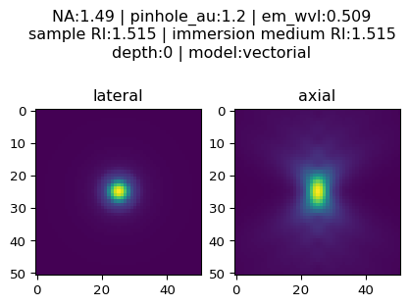
Note the symmetrical nature of the axial view when things are optimal.

Imaging with an oil immersion objective, depth=2
Even at a depth of 2 microns away from the coverslip, not much changes if the RI of the sample matches the RI of the immersion oil
ex_wvl = 0.488
em_wvl = 0.509
pinhole_radius = 25
mag_objective = 100
NA = 1.49
pinhole_radius_BP = backProjectedPinholeRadius(pinhole_radius, mag_objective)
airy_disk_radius = airyDiskRadius(em_wvl, NA)
pinhole_au = confocality(pinhole_radius_BP, airy_disk_radius)
oil_RI = 1.515
pz = 2
X1Params_high_res_index_matched_2um = {
"nx" : 51, # XY size of output PSF in pixels, must be odd
"pz" : pz, # depth of point source relative to coverslip (um)
"NA" : NA, # numerical aperture
"ti0": 150, # working distance of the objective (um)
"ni" : oil_RI, # immersion medium refractive index, experimental value
"ni0": oil_RI, # immersion medium refractive index, design value
"ex_wvl" : ex_wvl, # excitation wavelength (um)
"em_wvl" : em_wvl, # emission wavelength (um)
"ns" : oil_RI, # sample refractive index
"pinhole_au" : pinhole_au, # pinhole size (Airy units)
"model" : "vectorial",
}
PSF_fixed_2um = plotConfocalPSF(X1Params_high_res_index_matched_2um)
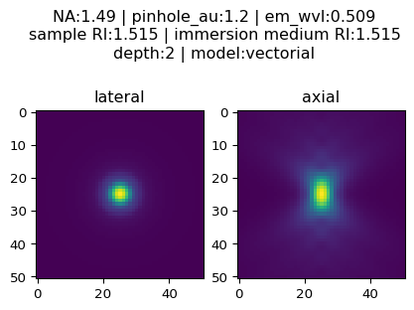

Imaging in DMEM with an oil objective at depth = 0
Then, let’s consider a realistic example: live-cell imaging in DMEM
ex_wvl = 0.488
em_wvl = 0.509
pinhole_radius = 25
mag_objective = 100
NA = 1.49
pinhole_radius_BP = backProjectedPinholeRadius(pinhole_radius, mag_objective)
airy_disk_radius = airyDiskRadius(em_wvl, NA)
pinhole_au = confocality(pinhole_radius_BP, airy_disk_radius)
oil_RI = 1.515
DMEM_RI = 1.34 # DMEM with 10% FBS
pz = 0
X1Params_livecell = {
"nx" : 51, # XY size of output PSF in pixels, must be odd
"pz" : pz, # depth of point source relative to coverslip (um)
"NA" : NA, # numerical aperture
"ti0": 150, # working distance of the objective (um)
"ni" : oil_RI, # immersion medium refractive index, experimental value
"ni0": oil_RI, # immersion medium refractive index, design value
"ex_wvl" : ex_wvl, # excitation wavelength (um)
"em_wvl" : em_wvl, # emission wavelength (um)
"ns" : DMEM_RI, # sample refractive index
"pinhole_au" : pinhole_au, # pinhole size (Airy units)
"model" : "vectorial",
}
PSF_livecell = plotConfocalPSF(X1Params_livecell)
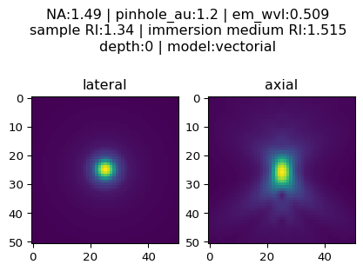

Imaging in DMEM with an oil objective at depth = 2
Axial resolution will deteriorate as the focus position moves away from the coverslip.
Let’s consider imaging at a depth of two microns
ex_wvl = 0.488
em_wvl = 0.509
pinhole_radius = 25
mag_objective = 100
NA = 1.49
pinhole_radius_BP = backProjectedPinholeRadius(pinhole_radius, mag_objective)
airy_disk_radius = airyDiskRadius(em_wvl, NA)
pinhole_au = confocality(pinhole_radius_BP, airy_disk_radius)
oil_RI = 1.515
DMEM_RI = 1.34 # DMEM with 10% FBS
pz = 2
X1Params_livecell_2um = {
"nx" : 51, # XY size of output PSF in pixels, must be odd
"pz" : pz, # depth of point source relative to coverslip (um)
"NA" : NA, # numerical aperture
"ti0": 150, # working distance of the objective (um)
"ni" : oil_RI, # immersion medium refractive index, experimental value
"ni0": oil_RI, # immersion medium refractive index, design value
"ex_wvl" : ex_wvl, # excitation wavelength (um)
"em_wvl" : em_wvl, # emission wavelength (um)
"ns" : DMEM_RI, # sample refractive index
"pinhole_au" : pinhole_au, # pinhole size (Airy units)
"model" : "vectorial",
}
PSF_livecell_2um = plotConfocalPSF(X1Params_livecell_2um)
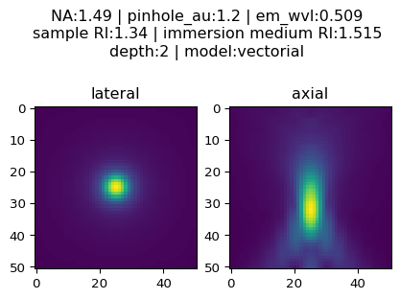
Note how much worse the axial performance is from the spherical aberration induced by RI-mismatch between the sample and immersion oil!

